SPOT ANALYSIS OF 20 DIFFERENT CONCENTRATIONS

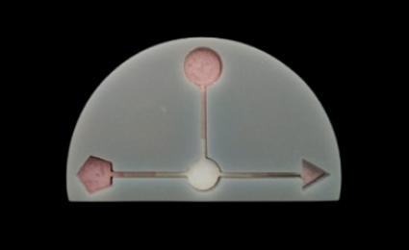  0 μM / 0 μM / 0 mM | 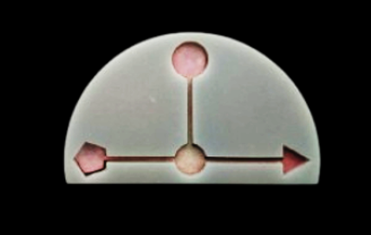  10 μM / 10 μM / 0.25 mM
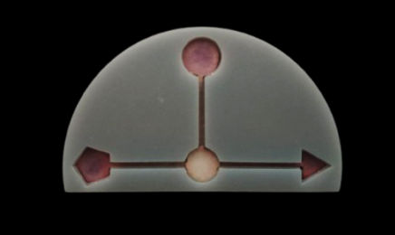  15 μM / 15 μM / 0.5 mM  ` | 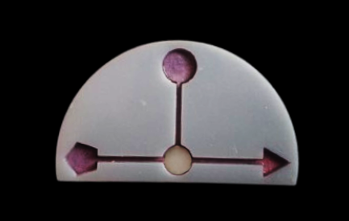  20 μM / 20 μM / 0.75 mM
`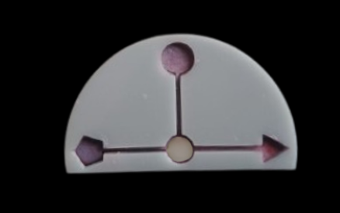  25 μM / 25 μM / 0.75 mM | `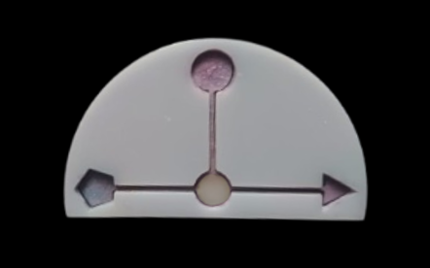  30 μM / 30 μM / 1.0 mM
``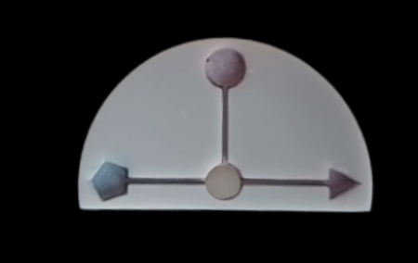  35 μM / 35μM / 1.25 mM | ``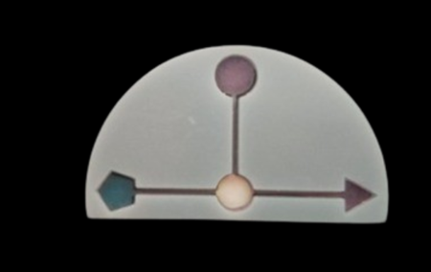  40 μM / 40 μM / 1.5 mM
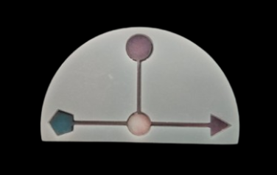  45 μM / 45 μM / 2.0 mM | 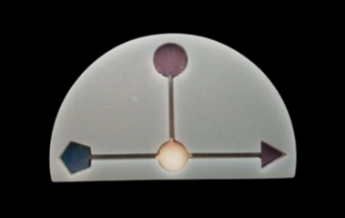  50 μM / 50 μM / 2.25 mM
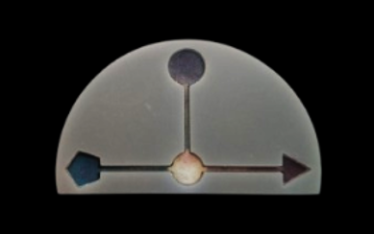  55 μM / 55 μM / 2.5 mM | 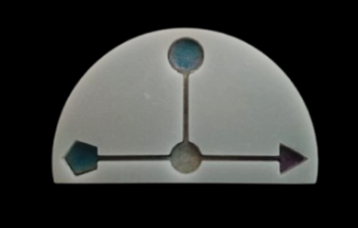  60 μM / 60 μM / 2.75 mM
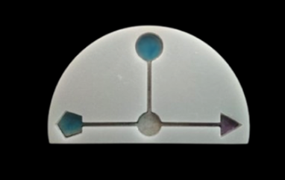  65 μM / 65 μM / 3.0 mM | 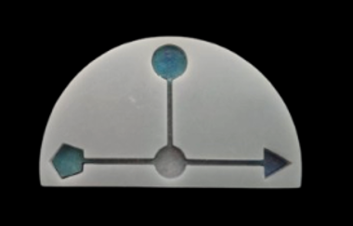  70 μM / 70 μM / 3.5 mM
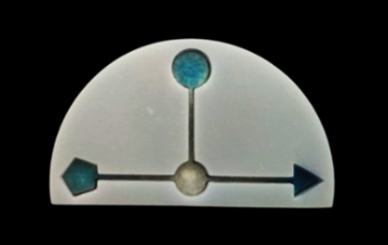  75 μM / 75 μM / 3.75mM | 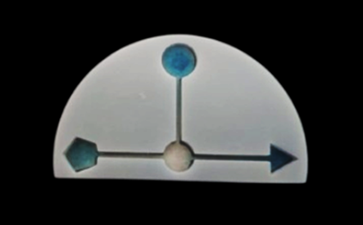  80 μM / 80 μM / 4.0 mM
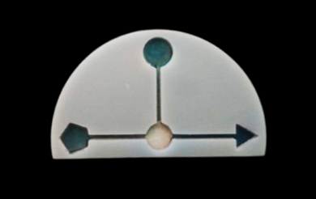  85 μM / 85 μM / 4.25 mM | 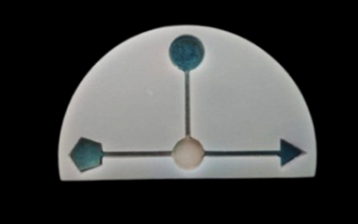  90 μM / 90 μM / 4.5 mM
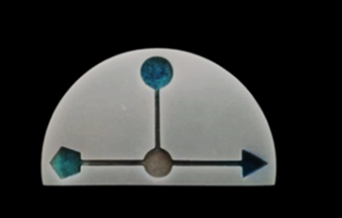  95 μM / 95 μM / 4.75 mM | 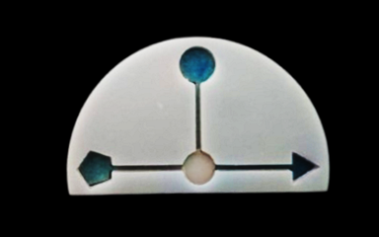  100 μM / 100 μM / 5.0mM

Cysteine RGB Analysis Red Graph

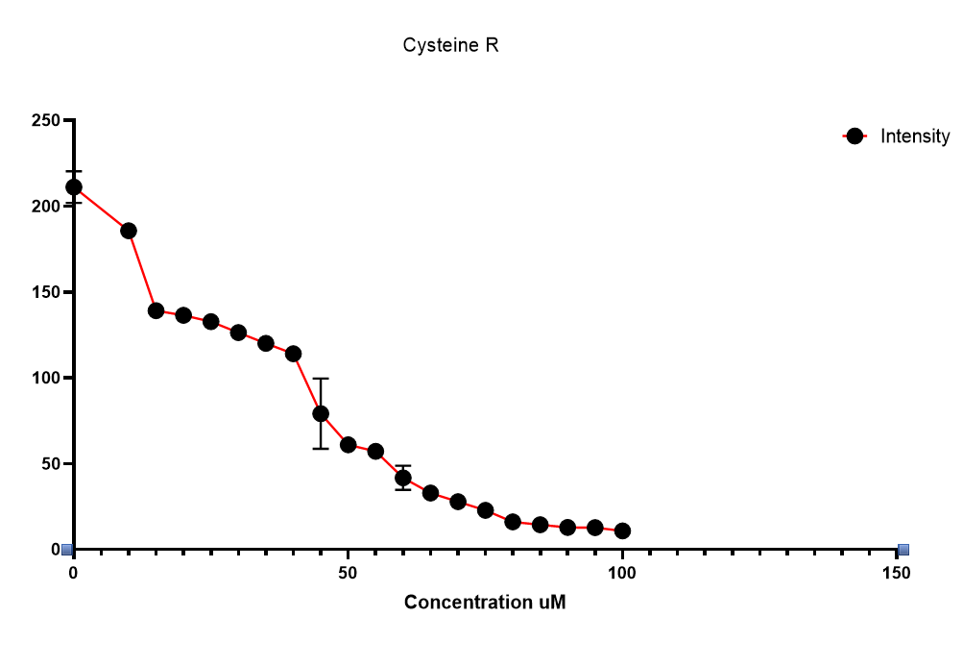

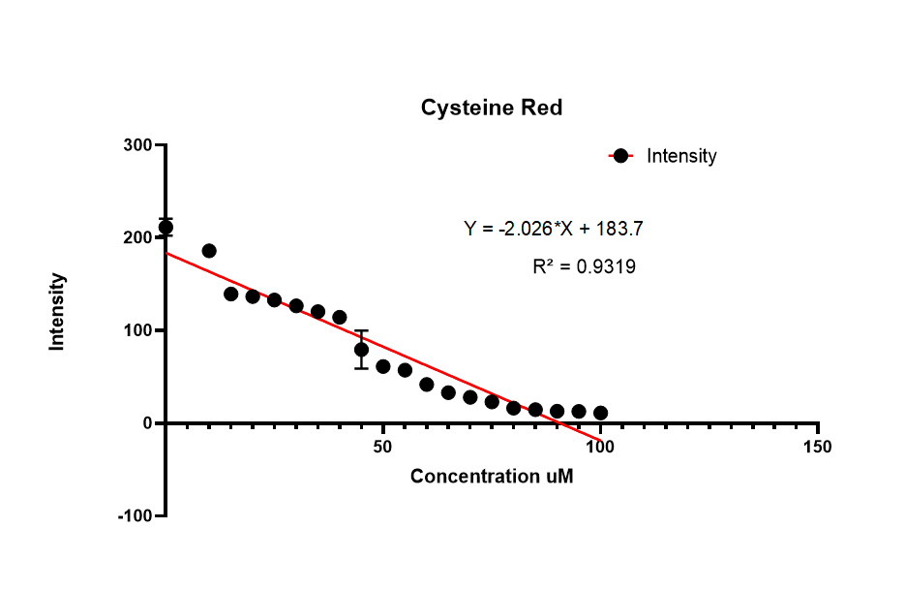

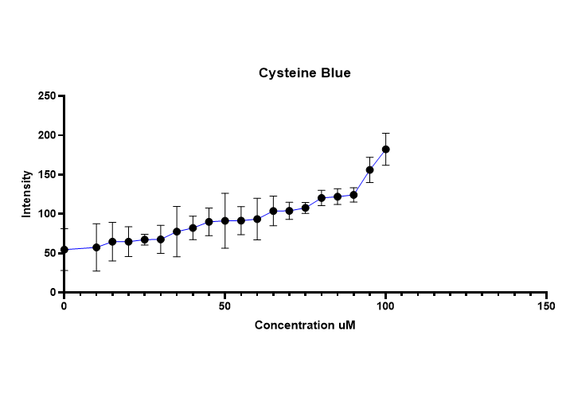

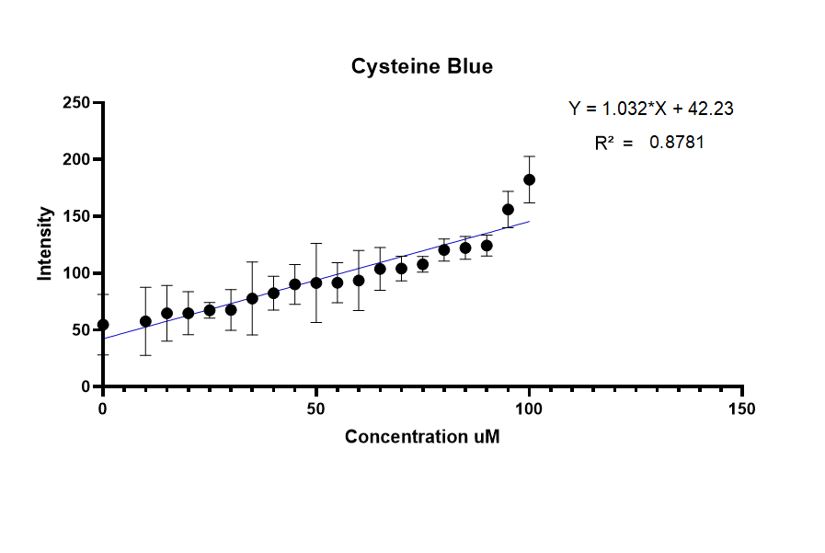

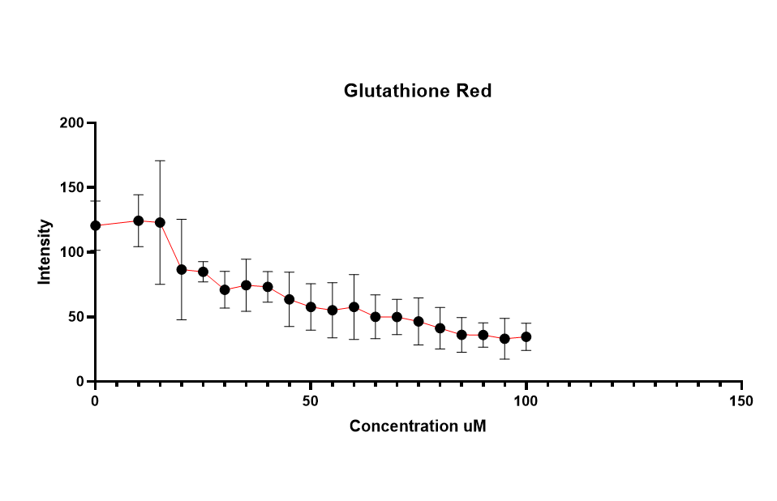

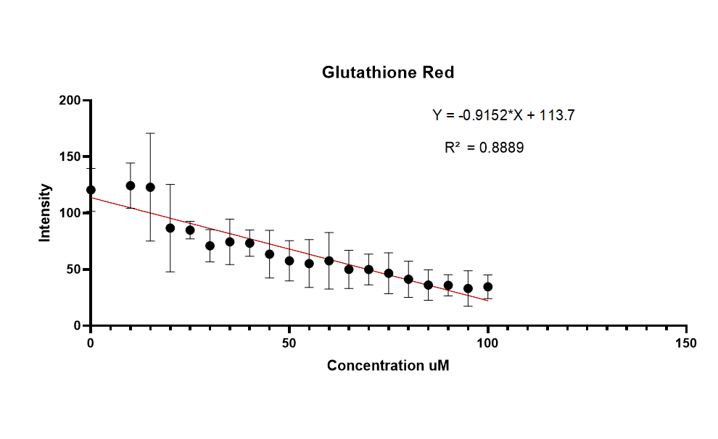

Glutathione Blue Graph

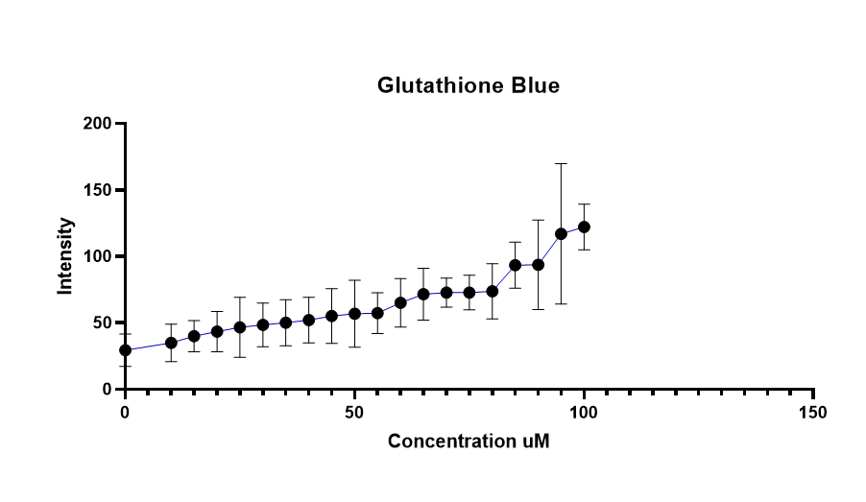

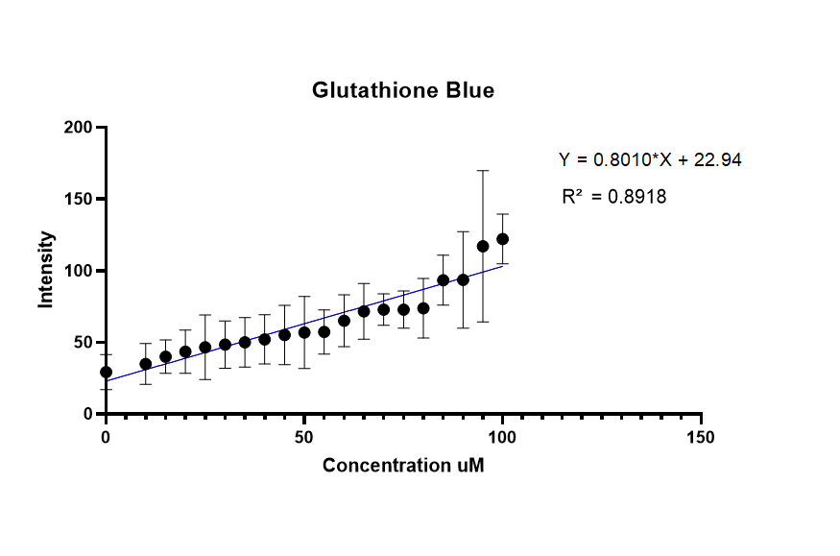

Sialic Red Graph
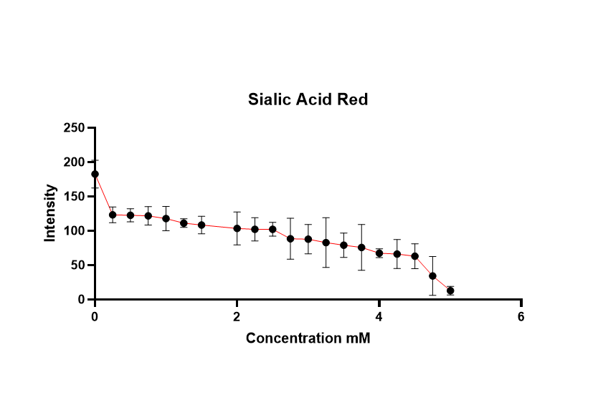

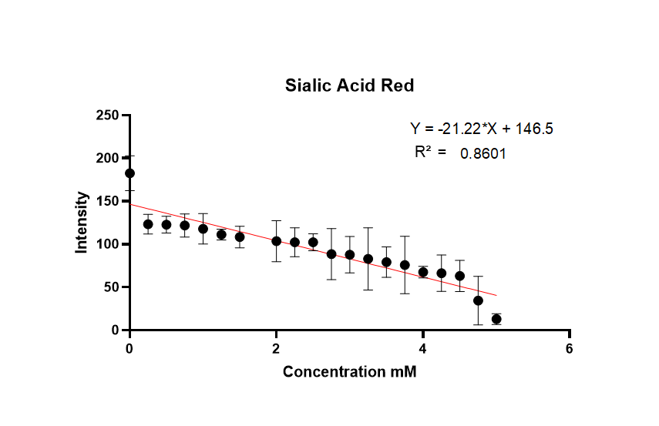

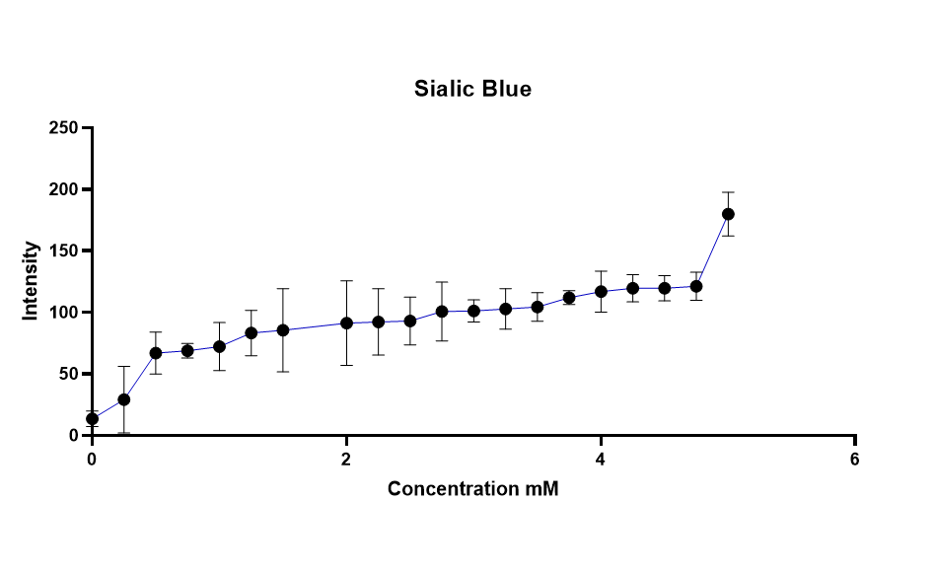

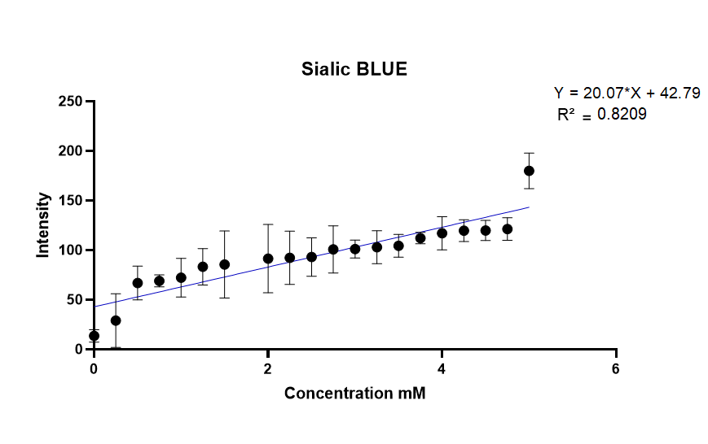

THANKYOU MAM

